OOPS NOTES
UNIT - I
Introduction of oops
Object-oriented programming – As the name suggests uses objects in programming. Object-oriented programming aims to implement real-world entities like inheritance, hiding, polymorphism, etc. in programming. The main aim of OOP is to bind together the data and the functions that operate on them so that no other part of the code can access this data except that function.
- OOP is faster and easier to execute
- OOP provides a clear structure for the programs
- OOP helps to keep the C++ code DRY "Don't Repeat Yourself", and makes the code easier to maintain, modify and debug
- OOP makes it possible to create full reusable applications with less code and shorter development time

Advantage of OOPs over Procedure-oriented programming language
Here are key advantages of Object-Oriented Programming (OOP) over Procedure-Oriented Programming (POP):
- Modularity and Reusability: OOP promotes modularity through classes and objects, allowing for code reusability.
- Data Encapsulation: OOP encapsulates data within objects, enhancing data security and integrity.
- Inheritance: OOP supports inheritance, reducing redundancy by reusing existing code.
- Polymorphism: OOP allows polymorphism, enabling flexible and dynamic code through method overriding.
- Abstraction: OOP enables abstraction, hiding complex details and exposing only essential features
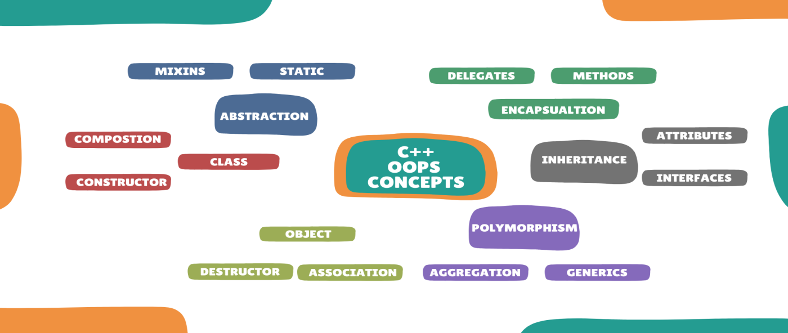
Characteristics of OOP

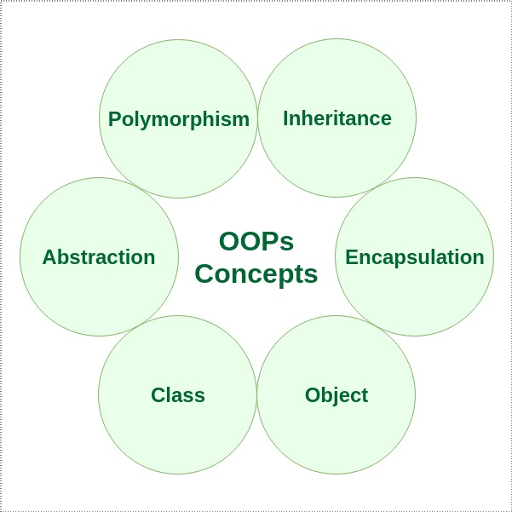

There are some basic concepts that act as the building blocks of OOPs i.e.
- Class
- Object
- Encapsulation
- Abstraction
- Polymorphism
- Inheritance
- Dynamic Binding
- Message Passing

1.Class
The building block of C++ that leads to Object-Oriented programming is a Class. It is a user-defined data type, which holds its own data members and member functions, which can be accessed and used by creating an instance of that class. A class is like a blueprint for an object.
A class is a user-defined data type, which holds its own data members and member functions, which can be accessed and used by creating an instance of that class. A C++ class is like a blueprint for an object.
For Example: Consider the Class of Cars. There may be many cars with different names and brands but all of them will share some common properties like all of them will have 4 wheels, Speed Limit, Mileage range, etc. So here, the Car is the class, and wheels, speed limits, and mileage are their properties.
- A Class is a user-defined data type that has data members and member functions.
- Data members are the data variables and member functions are the functions used to manipulate these variables together, these data members and member functions define the properties and behaviour of the objects in a Class.
- In the above example of class Car, the data member will be speed limit, mileage, etc, and member functions can be applying brakes, increasing speed, etc.

Example

class ThisClass {
public:
int var; // data member
void print() { // member method
cout << "Hello";
}
};

2.Object
An Object is an identifiable entity with some characteristics and behavior. An Object is an instance of a Class. When a class is defined, no memory is allocated but when it is instantiated (i.e. an object is created) memory is allocated.

3.Encapsulation
In normal terms, Encapsulation is defined as wrapping up data and information under a single unit. In Object-Oriented Programming, Encapsulation is defined as binding together the data and the functions that manipulate them.

4.Abstraction
Data abstraction is one of the most essential and important features of object-oriented programming in C++. Abstraction means displaying only essential information and hiding the details. Data abstraction refers to providing only essential information about the data to the outside world, hiding the background details or implementation.

5.Polymorphism
The word polymorphism means having many forms. In simple words, we can define polymorphism as the ability of a message to be displayed in more than one form. A person at the same time can have different characteristics.
C++ supports operator overloading and function overloading
.
- Operator Overloading: The process of making an operator exhibit different behaviors in different instances is known as operator overloading.

- Function Overloading: Function overloading is using a single function name to perform different types of tasks. Polymorphism is extensively used in implementing inheritance.

6.Inheritance
The capability of a class to derive properties and characteristics from another class is called Inheritance. Inheritance is one of the most important features of Object-Oriented Programming.

- Sub Class: The class that inherits properties from another class is called Sub class or Derived Class.
- Super Class: The class whose properties are inherited by a sub-class is called Base Class or Superclass.
- Reusability: Inheritance supports the concept of “reusability”, i.e. when we want to create a new class and there is already a class that includes some of the code that we want, we can derive our new class from the existing class. By doing this, we are reusing the fields and methods of the existing class.

7.Dynamic Binding
In dynamic binding, the code to be executed in response to the function call is decided at runtime. C++ has virtual functions to support this. Because dynamic binding is flexible, it avoids the drawbacks of static binding, which connected the function call and definition at build time.

Data Member and Member Function

Data Member Member Function

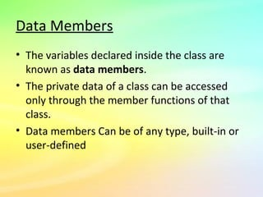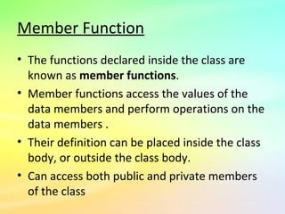

Structures in C++
Structures in C++ are user defined data types which are used to store group of items of non-similar data types. A structure is a user-defined data type in C/C++. A structure creates a data type that can be used to group items of possibly different types into a single type
Structures in C++ can contain two types of members:
- Data Member: These members are normal C++ variables. We can create a structure with variables of different data types in C++.
- Member Functions: These members are normal C++ functions. Along with variables, we can also include functions inside a structure declaration.
Example :-

#include <iostream>
#include <string>
using namespace std;
int main() {
struct {
int myNum;
string myString;
} myStructure;
myStructure.myNum = 1;
myStructure.myString = "Hello World!";
cout << myStructure.myNum << "\n";
cout << myStructure.myString << "\n";
return 0;
}
Difference in between structure and union
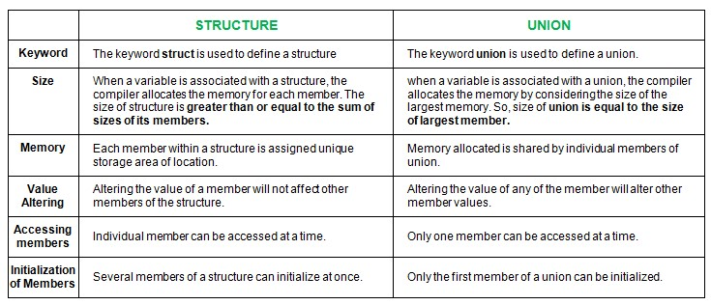

Access Modifiers/Access Specifer in C++

Access modifiers are used to implement an important aspect of Object-Oriented Programming known as Data Hiding. Access Modifiers or Access Specifiers in a class are used to assign the accessibility to the class members, i.e., they set some restrictions on the class members so that they can’t be directly accessed by the outside functions. Access specifiers in C++ are used to define the level of access that a class member variable or function can have. In C++, there are three access specifiers: public, private, and protected. The public access specifier is used to specify that a class member can be accessed from anywhere, both inside and outside the class. This means that any function or object can access the public members of the class. The public members of a class are typically used to represent the interface of the class.
There are 3 types of access modifiers available in C++:
- Public
- Private
- Protected

Note: If we do not specify any access modifiers for the members inside the class, then by default the access modifier for the members will be Private.

- Public: All the class members declared under the public specifier will be available to everyone. The data members and member functions declared as public can be accessed by other classes and functions too. The public members of a class can be accessed from anywhere in the program using the direct member access operator (.) with the object of that class.

Example

#include<iostream>
using namespace std;
class Circle
{
public:
double radius;
double compute_area()
{
return 3.14*radius*radius;
}
};
int main()
{
Circle obj;
obj.radius = 5.5;

cout << "Radius is: " << obj.radius << "\n";
cout << "Area is: " << obj.compute_area();
return 0;
}

- Private: The class members declared as private can be accessed only by the member functions inside the class. They are not allowed to be accessed directly by any object or function outside the class. Only the member functions or the friend functions/ friend class are allowed to access the private data members of the class.
we are not allowed to access the private data members of a class directly from outside the class. Yet an access to obj.radius is attempted, but radius being a private data member, we obtained the above compilation error.
However, we can access the private data members of a class indirectly using the public member functions of the class.

Example

#include<iostream>
using namespace std;
class Circle
{
private:
double radius;
public:
double compute_area()
{
return 3.14*radius*radius;
}
};
int main()
{
Circle obj;
obj.radius = 1.5;
cout << "Area is:" << obj.compute_area();
return 0;
}
3. Protected: The protected access modifier is similar to the private access modifier in the sense that it can’t be accessed outside of its class unless with the help of a friend class. The difference is that the class members declared as Protected can be accessed by any subclass (derived class) of that class as well.
Note: This access through inheritance can alter the access modifier of the elements of base class in derived class depending on the mode of Inheritance.
Example
#include <bits/stdc++.h>
using namespace std;
class Parent
{
// protected data members
protected:
int id_protected;

};
class Child : public Parent
{
public:
void setId(int id)
{
id_protected = id;

}
void displayId()
{
cout << "id_protected is: " << id_protected << endl;
}
};
int main() {

Child obj1;
obj1.setId(81);
obj1.displayId();
return 0;
}

Defining member function inside and outside the class

Class is a blueprint of an object, which has data members and member functions also known as methods. A method is a procedure or function in the oops concept. A method is a function that belongs to a class.
There are two ways to define a procedure or function that belongs to a class:
- Inside Class Definition
- Outside Class Definition

1. Inside Class Definition
The member function is defined inside the class definition it can be defined directly. Similar to accessing a data member in the class we can also access the public member functions through the class object using the dot operator (.).
// C++ program for Inside Class Definition
#include <iostream>
using namespace std;
class rectangle {
private:
int length;
int breadth;
public:
rectangle(int length, int breadth)
{
this->length = length; // this pointer
this->breadth = breadth;
}
int area() { return (length * breadth); }
int perimeter() { return 2 * (length + breadth); }
};

int main()
{ rectangle r(2, 3);
cout << "perimeter: " << r.perimeter() << endl;
cout << "area: " << r.area() << endl;
return 0;
}

2. Outside Class Definition
The member function is defined outside the class definition it can be defined using the scope resolution operator. Similar to accessing a data member in the class we can also access the public member functions through the class object using the dot operator (.).

#include <iostream>
using namespace std;
class rectangle {
private:
int length;
int breadth;

public:
rectangle(int length, int breadth)
{
this->length = length; // this pointer
this->breadth = breadth;
}
int area();
int perimeter();
};
int rectangle::area() { return (length * breadth); }

int rectangle::perimeter()
{
return 2 * (length + breadth);
}
int main()
{
rectangle r(2, 3);
cout << "perimeter: " << r.perimeter() << endl;
cout << "area: " << r.area() << endl;
return 0;
}

Inside the Class: A member function of a class can also be defined inside the class. However, when a member function is defined inside the class, the class name and the scope resolution operator are not specified in the function header. Moreover, the member functions defined inside a class definition are by default inline functions.
Outside the Class: Defining a member function outside a class requires the function declaration (function prototype) to be provided inside the class definition. The member function is declared inside the class like a normal function. This declaration informs the compiler that the function is a member of the class and that it has been defined outside the class. After a member function is declared inside the class, it must be defined (outside the class) in the program.

Array of Objects in C++

An array in C/C++ or be it in any programming language is a collection of similar data items stored at contiguous memory locations and elements can be accessed randomly using indices of an array. They can be used to store the collection of primitive data types such as int, float, double, char, etc of any particular type. To add to it, an array in C/C++ can store derived data types such as structures, pointers, etc. Given below is the picture representation of an array.
When a class is defined, only the specification for the object is defined; no memory or storage is allocated. To use the data and access functions defined in the class, you need to create objects.
An array of objects is declared the same as any other data-type array. An array of objects consists of class objects as its elements. If the array consists of class objects it is called an array of objects.
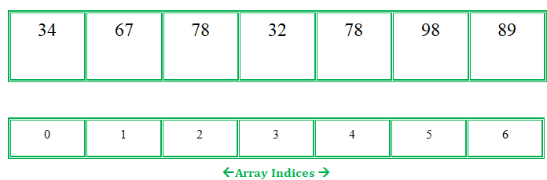

Example

#include<iostream>
using namespace std;
class Employee
{
int id;
char name[30];
public:
void getdata();
void putdata();
};
void Employee::getdata()
{
cout << "Enter Id : ";
cin >> id;
cout << "Enter Name : ";
cin >> name;
}
void Employee::putdata()
{
cout << id << " ";
cout << name << " ";
cout << endl;
}
int main()
{
Employee emp[30];
int n, i;
cout << "Enter Number of Employees - ";
cin >> n;
for(i = 0; i < n; i++)
emp[i].getdata();

cout << "Employee Data - " << endl;
for(i = 0; i < n; i++)
emp[i].putdata();
}

